

May, 2018 Newsletter
Prez Says
It’s that time again, when everyone is thinking of summer. Many are planning to be in a place that avoids the hot weather. I remember when I was teaching. For us May was time for historical movies to begin. When testing finished we all breathed a sigh of relief and reached for the popcorn.
As we wrap up the year, think of the many continuing challenges we face as an historical society. We are still awaiting the first hammer & nail sounds of renovation in Central Park in Davis at the WPA building where it has been a full 4 and a half years since the City Council gave us a victory over the forces of demolition. We are several months into a major confrontation with the Board of Supervisors over the Gibson House Historical Museum. Hope that matter ends with a preservation victory that takes months and not years to become definitive. We lost the effort to retain the whole old Carnegie Library in Yolo. However, in appropriate compensation, the residents will get a charming new building that reflects the Carnegie appearance and has space to accommodate the growing needs of the community. Surely that new Yolo Library will not take 52 months to achieved a “mission accomplished” status.
On the purely positive side, the Winters History Project is starting to fly and will form its own historical society and even have a building to tell their story. Congratulations! You GO! Winters! During the year we have met many wonderful individuals throughout the county who love history as much as we do. We also collected five new patrons including the Delta Protection Commission. Thanks to all of you who help support our projects. Your donations help our dues be reasonably low.
June is our last meeting of the year. We are going to have it at the Gibson Museum, because who knows how long that will be there to accommodate us as a matter of right. We saved it decades ago and at a crucial time we controlled it and even added an adjacent administrative office. Our annual meeting is on June 7, Thursday, from 5-7:00 at Gibson House. We will have the house open to tour, have a short meeting, and have time to meet and greet. Matt Stone will demonstrate 1860s baseball. See the article later in the newsletter.
Have a wonderful summer.
See you at the Fair!
Remember, as always, History Rules!
Kathy Harryman, President, YCHS

Below: a dozen youth from the Davisville and Tremont areas take a summer frolic in a Putah Creek swimming hole. Photo is courtesy of Bill Dietrich from the collection of his great aunt Thelma. Date unknown.

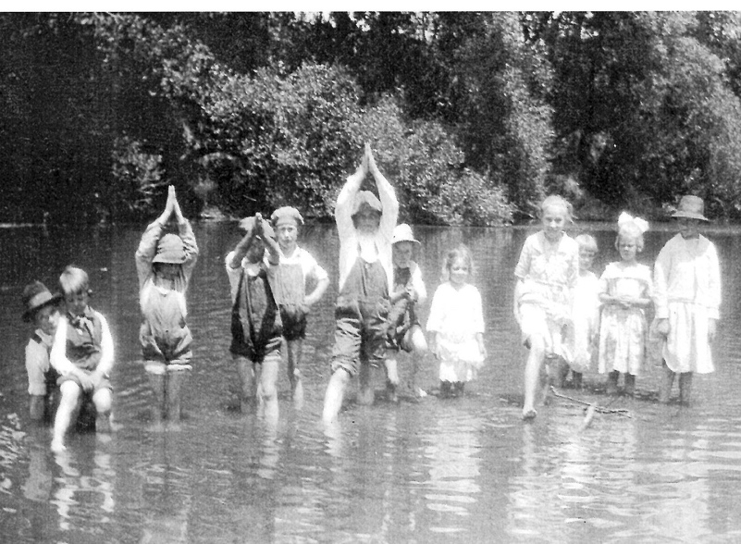

World War I
in Yolo County
by Larry Schapiro
(530) 304-6099
Far away from Washington, D.C., Yolo County residents read the words of President Woodrow Wilson in his April 2, 1917 war message to Congress in which he declared “our object now” is for a “concert of purpose and action.” With patriotic zeal, county locals eagerly joined the call to help support their country in the “War to End All Wars,” World War I. Days later, the Woodland Democrat announced that already “Yolo County [is] heeding the cry, cultivate to the limit.” (Woodland Democrat, April 5, 1917.)
Men from throughout the county enlisted. Five days after Congress declared war, “Heeding Uncle Sam’s call for volunteers, some of the best athletes ever developed at the Woodland high school today decided to enlist in the navy.” (Woodland Democrat, April 9, 1917.) Some Yolo County residents went to France with the American Ambulance Company. Their salary to help the wounded: 2 cents a day.
A draft quota was set for Yolo County. Over 2,500 came to the farewell to the first group chosen under the conscription act. A Woodland newspaper explained that the farewell was “the demonstration that every heart in Yolo county is going with these first 118 men to their training camps and to the front in a foreign land to fight the fight of democracy and justice.” (The Mail of Woodland, Sept. 5, 1917.)
Woodland women organized into groups and met at the grammar school auditorium to make supplies for the naval base hospitals. The Woodland Fire Department held a benefit dance and sent the $163 proceeds to Woodland National Guard Company F at their training camp in Richmond. Already a leader in Woodland affairs in 1917, the Woodland Elks unanimously voted to purchase $1,000 worth of Liberty Bonds.”
For Memorial Day in 1917, the Woodland City Council passed a resolution asking all merchants “with the exception of those who conduct restaurants and soda fountains, to close next Wednesday, Memorial Day.” The Daily Democrat reported that “No Woodland merchants objected” and in fact decorated their stores “in the national flags, bunting and other patriotic emblems.” (Woodland Democrat, May 26 and 28, 1917.) With a county population of 13,925, over 12,000 gathered in Woodland for the Memorial Day parade, with more than 3,000 of that number participating in the parade. For the war effort, by summer of 1917, Yolo
County increased its crop production to $7,000,000 over the prior year, raising crops worth over $20,000,000. The farmers did not forget the soldiers. Lieutenant Hill of Company F announced that the company was receiving an average of 12 boxes of fresh fruit every day from different sections of the county.
parade, with more than 3,000 of that number participating in the parade.
For the war effort, by summer of 1917, Yolo County increased its crop production to $7,000,000 over the prior year, raising crops worth over $20,000,000. The farmers did not forget the soldiers. Lieutenant Hill of Company F announced that the company was receiving an average of 12 boxes of fresh fruit every day from different sections of the county.
Sadness comes with war. Periodically the Armed Forces reported the death of a Yolo County resident. Others were blinded or incurred severe lung damage due to the German Army’s use of poisonous gases. William Oliver, who lived two miles outside of Woodland and had raised crops for raisins and prunes, was one of those who died in battle, leaving sadness and pain for his large family.
Private Oliver wrote to his mother Rose from France less than two weeks before his death “You mentioned that you wanted me to have my picture taken. If I can get to go to some large town I will have one taken and sent right away.” But the photograph for mom was never to be. Death came first. Mrs. Rose Oliver instead received a Western Union telegram from the Army Adjutant General reading simply: “Deeply regret to inform you that Private William F Oliver is officially reported as killed in action.” Three years later, his body was returned to Woodland. His schoolmate, Amelia McGrew, wrote:

I remember as if it were yesterday
The brave heart and that smiling face
That left us speeding far away
To help make France a safer place.

Before World War I was over, 31 other Yolo County mothers received the same telegram notifying the family of the tragedy of lost sons, brothers, husbands, and fathers.

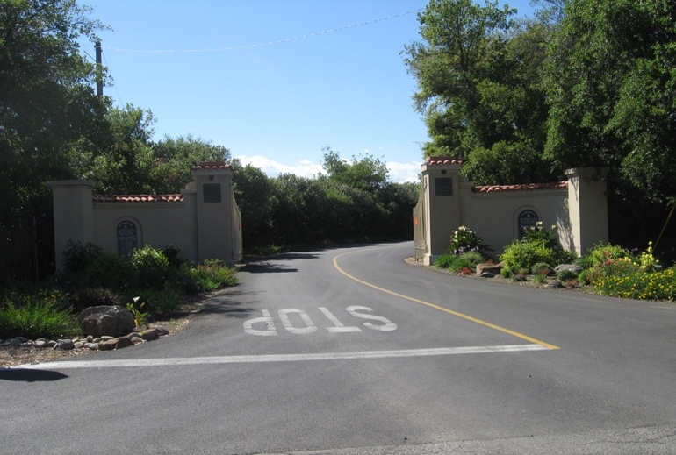

The three photos above show the Flyers Club entrance where a
WW I memorial names on two
Plaques those who died at war.
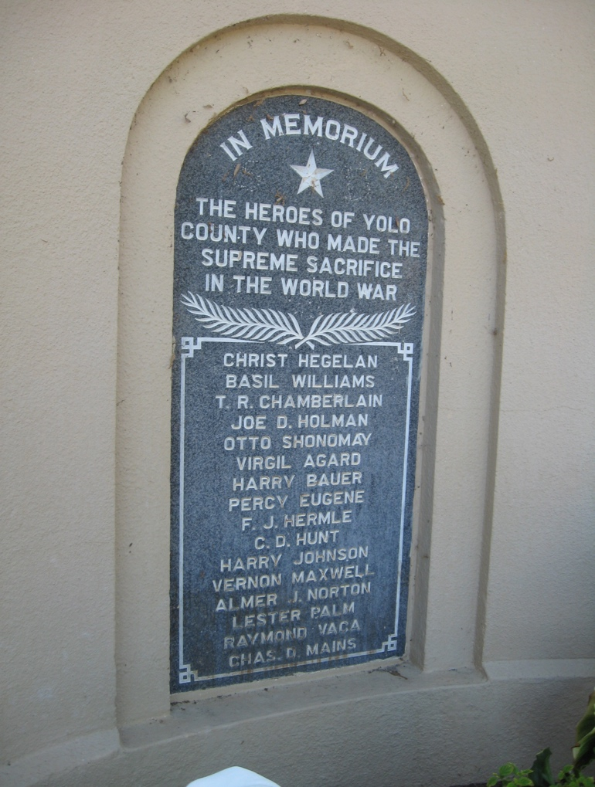

INCLUDEPICTURE "https://lh3.googleusercontent.com/4eRH9O5iwoqToN6EgFw_bVskg9sqaWO8LDFXbRG08LMJ2StjjDEC61IWaww-yqI8SQgP=s90" \* MERGEFORMATINET INCLUDEPICTURE "https://lh3.googleusercontent.com/4eRH9O5iwoqToN6EgFw_bVskg9sqaWO8LDFXbRG08LMJ2StjjDEC61IWaww-yqI8SQgP=s90" \* MERGEFORMATINET INCLUDEPICTURE "https://lh3.googleusercontent.com/4eRH9O5iwoqToN6EgFw_bVskg9sqaWO8LDFXbRG08LMJ2StjjDEC61IWaww-yqI8SQgP=s90" \* MERGEFORMATINET INCLUDEPICTURE "https://lh3.googleusercontent.com/4eRH9O5iwoqToN6EgFw_bVskg9sqaWO8LDFXbRG08LMJ2StjjDEC61IWaww-yqI8SQgP=s90" \* MERGEFORMATINET 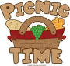 Meet/Greet Society members Th. June 7th. 5:00 to 7:00. Brief Annual Meeting at 6:00
At OUR Gibson House Museum
[suggested pot luck fare]
A-L Bring salad
M-S bring a dessert
T-Z bring bread
If you can, bring to serve 6
Drinks & lasagna for all from YCHS

Gibson House
Museum In Danger
By Kathy Harryman

This is a difficult story for me to write. We have all fought hard to keep this museum an historical place. You have written letters, called your supervisors, spoken to friends and have rallied the historical community of this county. After the March 22 meeting at the Woodland Community Senior Center and the outpouring of concern and fear that the museum would be taken over by Yolo Arts, we were all told that the information received at that meeting would be taken to the Board of Supervisors and that, in the meantime, all progress would stop until the supervisors give further direction. The supervisors were going to meet and discuss the future of the Gibson House Museum on Tuesday, May 8. Many of us received post cards saying that the meeting would be postponed until Tuesday, June 26. The reason given was that they were awaiting the results of the election replacing Matt Rexroad ‘ from his supervisor position.
I am now going to share a letter that was written by Carolyn West, the Senior Management Analyst to one of our members. Our member’s concern was the sustainability of funding, control of the funding, and what portion of the funding will be derived from Yolo County Taxpayers.
Here is her response:
“Under the implementation plan proposed, operation of the Gibson House as a cultural center would be conducted by YoloArts. Therefore YoloArts would be responsible for obtaining revenue to fund operations at the site.
YoloArts has provided an estimated 3 year operational budget to outline their funding plan.
The county wants to see operations that are strong and self-sufficient. However, the County’s goals are not just self-sufficiency for the Gibson House operations; we are also wanting to see enhanced educational programming, etc. We understand that YoloArts will need time to develop and grow their operations. Annual check ins and Board updates would be a way to monitor their progress.

Does this sound like a done deal to you? It sure does to me and to the individual who received the letter. Have the supes already met and made a decision in violation of the Brown Act? My big question is “Who is running the county?” Our elected officials or the employees at the county office? Why wasn’t there a paragraph addressing the fact that all is up in the air awaiting the approval of the supervisors?

If you would like to read the entire letter, I will put it on our website.

What can we do now? Going to the meeting on June 26 is very important. Continuing to talk to your supervisors is also important. Talk to your friends and their friends throughout the county. Continue to write letters. If your district is up for re-election, carefully consider who you are voting for.
History Rules!

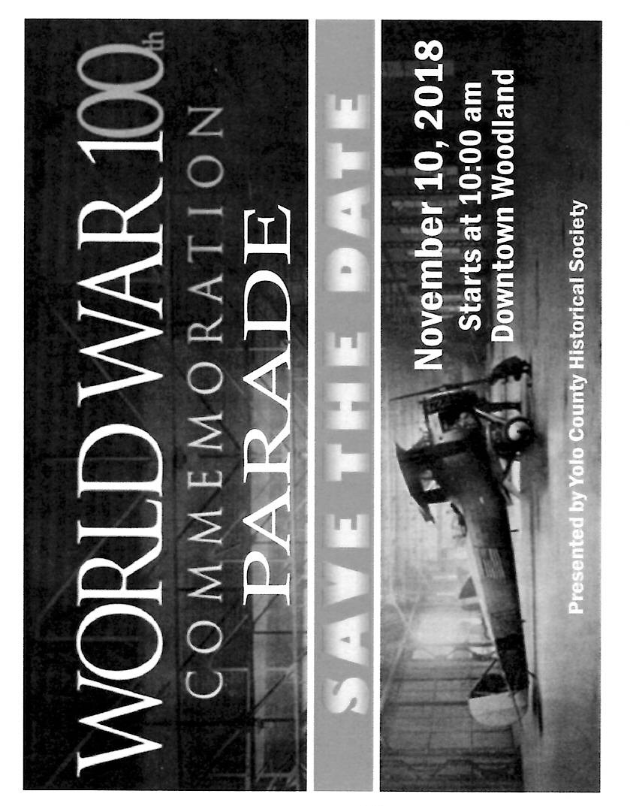

World War One Tidbit:
Draft cards might be expected to record name, height, weight, hair color, eye color. For what reason did they ask whether “bald?” Offer possible logics for recording hairlessness (but not beards).

Little Things Mean a Lot
By Kathy Harryman

Have you ever found something, picked it up, looked at it and said, “I wonder?”. If you have had that experience often, then you might be an historian. Wondering about something is what historians do best. I recently received a book from the Holy Rosary Academy Library from a friend of mine. She thought that Holy Rosary School would like the copy since it came from the original Academy. I said sure, I’ll take it. The book title was St. Gemma Galgani written by Rt. Rev. Dr. Leo Proserpio, S.J. and was published in 1940. I am sure this book should have been a best seller, but unfortunately only one individual had signed it out during its time HRA. How do I know this? Remember the pockets and the Seven Day due date in the back of the books! But that wasn’t the best find for me. There was a lined paper torn out of a notebook 2 x 5” with the following written:

West Coast Train
Leaves Woodland at 5:15 p.m. Sunday
Arrives at Fresno
12:35 a.m Monday

After reading this note, the questions began. Who wrote this note? Was it a student who boarded at the Academy? Were they going home? Was it someone who wanted to visit a student? Was it an adult who wanted to visit? Did Woodland have trains that went directly to Fresno? Was this a passenger train or a cargo train or both? Seven hours seemed to be a pretty fast schedule.
Needless to say, there were no answers and just questions and lots of “I wonder?” What’s going to happen to the artifacts? The book will go to Holy Rosary School and the piece of paper will go to our local train museum as just a small piece of the past. ‘I wonders’ are fun and can be engaging.
❖
Business Buddies
The following businesses in town have financially supported the Yolo County Historical Society. We would like you to support them and keep your money local:

L & S Printers, Main St.; Chamberlain Farms
Larry Shapiro; Bernard & Lynne Gough; Corner Drug; Delta Protection Commission; L & S Printing; The House Dresser; Dahlin & Essex Inc.; Bill Marble; Michele Giguiere; Tom & Meg Stallard

If you know of any business that would like to join our support list, contact me. Businesses pay $50.00 per year for advertising.

2017-2018 Patrons: Thanks to the following for generously supporting the Society. You too can be a Patron by donating $100.00 to help us run our projects.
Alice Wong & Ryan Baum; Cleve Baker
Jeff & Starr Barrow: Edmund & Margie Blake; Odette & Dana Christenson; Donald & Pat Campbell; Katherine Cobb; Robert & Elizabeth Coman; John & Helen Daniels;
Jonathan & Barbara Durst; Delta Protection Commission; Marc & Gerda Faye; John & Kathy Harryman; Joan Hagen; John Hoover; Dan & Sarah Hrdy; Richard & Joann Larkey; Steve & Teri Laugenour;
Jane Niehues; Charles & Claudia Owens
Marcia Reemts; Roger & Ann Romani; Richard & Evelyne Rominger; Ronan & Marilyn Scholz; Robert & Judy Simas; Michael Truitt & Albin Family; Ramon & Karen Urbano; Lynn & Penn Wilen; Benjamen & Sandra Wright; Tom Crisp.

Please think of contributing a story, a news item, or a photograph to your Newsletter. These can go to President Kathy or you can Contact or send items to (interim) Newsletter Editor Dennis Dingemans at rddd@dcn.org or at his 645 C Street home or 530-753-5959. He can be found 10 am to 4 pm most Wednesdays and Saturdays at the Hattie Weber Museum of Davis History.

Mary’s and Me
By Nancy Rice
Part 2 of 2
There was a reason for me to want to find the Hubbard grave. Despite two other stones and the large tree in the plot, there was room for more burials. My grandmother, who was born in Yolo County, was old at that time, the early ‘50’s. She would need a resting place, and what could be more appropriate than beside her grandfather Hubbard? So,my search of records began and signatures for releases were obtained. When the time came my grandmother shared Nelson’s stone with her data engraved on the west side. My grandmother’s burial was one of the first burials of cremains. Grandma was a pioneer believer in cremation, a very controversial practice in her generation.
More years passed. We visited from time to time. My mother and her sister decided to be buried at the sides of the obelisk; my mother to the north and my aunt on the south. Naturally their husbands would be buried at their sides. The plan was to have all their data incised on the obelisk. But there was not enough space for the husbands’ data too. My mother in 1990 was the first of that generation to be buried there. The gravestone was laid four years later. The delay was to determine what to do, since the writing wouldn’t’ fit, and because of problems coordinating the process. So her ashes ended up next to the Hubbard stone, on the north, with a granite duplex pillow stone overhead. My father’s ashes joined her’s soon after. We were told at that time there was enough room for twenty-six more cremains in our family plot, provided they were buried two deep. Hmmm, a regular small town in the Hubbard plot!
There was another population influx to our family plot in 2002. First was my husband and his stone was another granite duplex pillow. The day was blustery, windy, cold, and pouring rain. But when we left the chapel, there was sunshine and a double rainbow to the east—simply beautiful and much like a blessing. I had asked my sons to lower the cremains into the ground. Just as they had them lowered, the cemetery caretaker popped out from behind the oak tree like an elf, whisked the box out of my sons’ hands and put it in the ground himself.
The second burial in 2002 was my aunt. The late spring day was windy and cold. I had a feeling of foreboding. The hole in the ground was in one corner of the plot, far away from the Nelson Hubbard obelisk, as if she were exiled from the family. My aunt was going to be buried in the wrong place! Should I disrupt everything and insist that another hole be dug right now? I decided to wait. After a couple of days, I made the needed phone calls. The second burial was quite informal, even chatty, with only the local family and the gravedigger. What a relief, whew!
Again, time has passed. During this peaceful period visits have been with friends as well as family. Friends are often surprised to find such a place out in the fields and sometimes they are pleased to see where their friends are buried. A special occasion is the early morning service at Easter. I like to bring my family for the service in the chapel and to visit the grave-side. This is a new tradition in the making.
I expect this wonderful place will be my final home on earth and hopefully that of my children. It is a good resting place, under the old oak tree at Mary’s.

I owe many thanks to Mary Jane Hawes and Wilma Cuthbertson for verifying my facts and supplying me with a booklet on the history of Mary’s.

The above is the second part of an article written by our member, Nancy Rice. We welcome personal reflections of life in Yolo County. If you would like to share and be published, please send your draft to Yolo County Historical Society P O Box 1447, Woodland Ca 95695

Yolo County Historical Society
P O Box 1447
Woodland, CA 95776

Address Service Requested

Dated Material
Vision Statement The Yolo County Historical Society strives to preserve, protect and acknowledge the diverse history of Yolo County through education, communication and
advocacy

